Document: | Skills Passport
Version number : | 1
Date this version approved: | 24/4/21
Approving committee: | PIF
Author(s)  (job title) | Gemma Hurst
Division/Directorate: | Corporate
Trust Wide (Yes/No) | Yes
Links to other Strategies, Policies, SOP’s, etc. | Preceptorship

Date(s) previous version(s) approved:  (if known) | Version:  1 | Date :  24/4/21
DATE OF NEXT REVIEW: | 24/4/24
Manager responsible for review:  (Job title) | Professional Practice Practitioner

Skills Passport
(For Deployed, New, NHSP and Agency Staff)

Staffs are all responsible for completing this passport
Name
Role
Line Manager Name
Date Commenced

Mandatory Training Declaration and Corporate Induction

 | Date completed | Signature
Mandatory Training completed
Corporate Induction completed
Extended Clinical Induction

Contents

Welcome to Wrightington, Wigan and Leigh Page 2
What is the Skills Passport for Deployed, New and Agency staff? Page 3
Roles and Responsibilities Page 3
Pledges Page 4
Preparation for working with WWL Page 5
SWOT Analysis Tool Page 6
The role of a nurse Page 7
Essential skills and competencies Page 7
All registered nurses (Core skills) Page 8
Appendix 1 - Community skills Page 15
Appendix 2 - Emergency care Page 16
Appendix 3 – ICU Page 19
Appendix 4 – Medicine Page 20
Appendix 5 – Respiratory Page 21
Appendix 6 – Surgical Page 22
Appendix 7 - Diary Log Page 23
Appendix 8 - Reflective log Page 25
Appendix 9 – Local Induction Checklist for Agency Staff Page 26
Appendix 10 – Discharge Checklist Page 27

Welcome to WWL

Welcome to WRIGHTINGTON, WIGAN and LEIGH teaching hospitals NHS Foundation Trust where;

"Our Patients are at the Heart of Everything we do".

Here at WWL our aim is the continuous improvement of services and facilities for patients, staff and visitors. In order to meet our aims we channel our efforts into five guiding principles. These five principles underpin every aspect of our work both within the Trust and within the community as a whole. In addition to our guiding principles, our mission statement is clear “Our Patients are at the Heart of Everything we do”.
The principles are:
- Provide effective, responsive services of high quality
- Ensure that services are integrated and co-ordinated
- Ensure that the staff feel valued and to make the best use of their abilities
- Use our resources efficiently
- Make our services locally accessible as far as possible

WWL is an innovative and forward thinking trust, dedicated to providing the best possible healthcare for the local population of over 300,000.
“A very warm welcome to you in joining the WWL family”.

What is the ‘Staff Passport for Deployed, New and Agency Staff’?
This document is intended to be used as a model of enhancement, which acknowledges you as a safe, competent but novice practitioner who will continue to develop and evidence your competence throughout your time working within WWL.

Our vision is that alongside the core skills and knowledge requirements we can build this document to reflect all the different divisions and areas you may be required to work in. This Includes looking at your personal requirements whilst encompassing previous skills, knowledge and experiences ensuring equitable access and outcomes from the process.

Roles and Responsibilities
The staff member (you) should seek to identify your mandatory training as soon as possible after appointment. Together with your contact you will identify objectives required and specific learning needs to facilitate an action plan for addressing these. You will also seek feedback on your performance and reflect on your practice and experience. (NMC, 2006)

Pledges
The use of a pledge is thought to be an effective approach to set forth and deliver commitments to patients, employees and employers. This approach has been adopted by the NHS Constitution who has made the following pledges below and in view of this have committed to the idea of supporting staff.

Staff member pledges:
- Ensure orientation is done.
- Ensure you have read the ward induction booklet and understand the general routine
- Commit to the role and strive to ensure that your knowledge and skill is up to date and in line with best practice guidelines and you emanate the trusts core values.
- Provide honest, constructive feedback with respect.

Print Name: Signature: Date:

Line Manager’s pledges (to be agreed on appointment):

- Ensure that I understand the staff members competencies and delegate appropriately
- Full orientation to ward is completed along with general area’s ‘normal routine’
- Ward areas induction booklet with all relevant ward information including door codes and emergency contact numbers.

Print Name: Signature: Date:

Preparation for working with WWL

Before your initial shift take the time to think about your current and previous experience and knowledge:

- What can be transferred?
- What do you need to work on?

Please use the SWOT analysis tool included to reflect on this before your first Shift. This can be re used throughout your time with WWL to reflect on your progress and identify areas for development.
SWOT Analysis Tool

STRENGTHS | WEAKNESSES
OPPORTUNITIES | THREATS

The Role the Nurse
4ward Thinking
We seek out new and creative way of working to make a positive difference.
Working together
We actively seek opportunities to work in partnership with others
Accountable
We take personal responsibility for ourselves and our actions
Respectful
We recognise that everyone counts and makes a valuable contribution
Demonstrate Compassion
We take time to show kindness and care to others whilst providing a wide range of nursing interventions to people, in a ward environment, their own home, treatment room and clinic setting, and playing a key role in supporting independence, managing long term conditions and preventing deterioration of acute illness

Essential Skills and Competencies

- Excellent verbal, written and interpersonal communication skills
- Ability to maintain and improve standards of care
- Ability to challenge unacceptable behaviour or practice in a professional context
- Up to date knowledge of current clinical and professional issues
- Knowledge of evidence based practice
- Understanding of research/audit
- Understanding of education/student requirements
- Flexible and positive approach to work
- Speak English to an appropriate standard relevant to their role, i.e. with confidence and accuracy, using correct sentence structures and vocabulary, and without hesitation
All Nurses (core skills)
These skills are essential for all registered nurses to practice at a basic level in a majority of clinical areas, although some still may be N/A in some areas.
Please also see the related Appendix for the work area you are working in for further skills you may need or already have that are needed to work in those areas.
Staff are expected to keep this record up to date and continually develop themselves in skills they may be lacking.

Skill | Procedure | Method of Delivery | Evidence/Competency | Complete  Sign &Date
FFP3 Mask Fit Test | All staff will need to be Mask Fit Tested | Face to face  Please contact Cheri Herring for dates and time ext. 2278  Dates will also be advertised in the COVID-19 Communication Newsletter
Deliver care within the Medical Setting. | Ensure privacy and dignity Is maintained whilst working on a medical ward..  Assistance with personal hygiene. Pressure area care  Nutrition & Hydration support and monitoring  Be aware patients who are nursed on a DOLS, or Section.  Ensure awareness of interpreting pain in individuals who cannot communicate. | ClinicalSkills.net  Familiarisation with pain tools such as Abbey pain tool.
Referrals | Completion of referrals to specialist teams, e.g. ACST, Safeguarding, RAID and Alcohol Nurses. Adult Social Care, district nurses & Hospital at home upon discharge | Cascade training at Departmental level
HIS Access |  | Given once eLearning modules completed
Clinical Observations/NEWS2 | Take, record and interpret vital signs manually;  undertake, respond to and interpret neurological observations using the Glasgow Coma Scale and assessments.  Identify and respond to signs of deterioration and sepsis using A-E assessment and use of SBAR  Initiating assessments to aid in diagnosis eg, ecg, hcg ,urine dip, blood ordersets | E-Learning NEWS2  RN Upskilling Programme  Extended Clinical Induction  Recognise & respond to deterioration in the elderly - Elderly Care Programme  AIMs | Completion of Competency Workbook
Risk Assessment | Completion of the following risk assessments:  Nutrition, Falls, Bedrails, Waterlow, SSKIN, Moving and handling | Clinical Induction  RN Upskilling Programme
Falls Management | Manage risk of falls using risk assessment tool.  Respond to and manage the care post falls using escalation tool | Clinical Induction  RN Upskilling Programme
Sepsis Toolkit | Recognise and respond to signs of sepsis | E-Learning  Clinical Induction
Nursing Admission and Assessment | A holistic assessment of the patient which includes whole body systems assessment including respiratory, circulatory, neurological, musculoskeletal, cardio-vascular and skin integrity.  *Skin assessments this will include the completion of DATIX and referral to Safeguarding for multiple Category 2, Category 3, 4, unstageable pressure ulcers and SDTI | HIS E-Learning Modules 1, 2 & 3  Safeguarding Level 2 E-Learning  Safeguarding Level 2 Face to Face training
Care Planning and Evaluation | Undertake full and accurate assessments of nursing care needs and develop person centred care plans | Extended Clinical Induction a  His e-learning modules
Safe Nursing transfers/Discharge | Discharge patients safely from the Department to their place of residence or new place of residence.  Transfer patients safely to other wards.  Completion of the Handover/Patient Transfer form for patients being admitted.  Undertake a comprehensive handover to receiving ward/department .  Aware of Discharge to Assess process  Ensuring correct documents/equipment/medication leaves with patient, e.g discharge letter, DNACPR, medication. | Cascade training at Departmental level
Nursing Discharge | Discharge patient safely from the inpatient areas, including referrals to appropriate agencies and medication on discharge | Clinical Induction  Elderly Care programme – aligned to community pathways
Medicine Administration | Administer medication via a range of routes.  Undertake accurate drug calculations for a range of medications and routes.  Redeployed Nurses will need to complete the Medicines Safety Workbook | Clinical Induction  Medicine Safety Training  E-Learning  Competency Workbook | Completion of the Medicine Safety Workbook and Competencies
IV Medication and IV Therapy | This includes the administration of IV medication and the administration of I V fluids and management of infusion pumps | IV Study Day | Completion of Competency Assessment
Pain Management | Use pain assessment tools to objectively assess pain  Apply appropriate non-pharmacologic strategies for the  management of pain (i.e. positioning, dressings)  Administer prescribed analgesia via a variety of routes. Ensure the correct use of pain using tools such as Abbey Pain Tool.  Evaluate the effectiveness of analgesia at appropriate times  following administration and escalate appropriately where pain  remains unmanaged. | ClinicalSkills.net  Cascade training at Departmental level  Medicine Safety Training  Extended Clinical Induction | Pain Management
Blood Glucose Monitoring | Obtain capillary blood sample, measure and interpret Blood Glucose Levels | Medical Devices Training E-learning and Clinical Induction  Cascade training at Local/Departmental Level  Clinical Skills.net
End of Life Care | This includes: understanding Advance Care Planning. Identifying and responding to symptoms and signs of distress, pain, nausea, thirst, constipation, restlessness, agitation anxiety and depression. Providing care based on the wishes of the patient and family and carers. Understanding and apply DNACPR decisions.  Providing care for the deceased person and their family respecting cultural requirements and patient wishes | Clinical Induction  RN Upskilling Programme  E-Learning Module
Nasal and Oral Suctioning | Removal of Oral secretions using a rigid plastic suction catheter (yankeur) and nasal secretions using a flexible plastic suction catheter | Clinical Skills.net  Cascade training at Local/Departmental Level
Female Catheterisation | Use of evidence based assessment tool e.g. HOUDINI.  Insertion and management of urethral catheter use of catheter passport | RN Upskilling Programme  ClinicalSkills.net
Male Catheterisation | Use of evidence based assessment tool e.g. HOUDINI.  *if identified as required Nurses are required to complete a Trust Competency Framework in order to insert male catheters. If required will need to undertake the Trust Training programme and assessment of competence | Trust Training Delivered by the Urology Team | Completion of Competency Assessment
Cannulation | Undertake cannulation and manage cannulas, completion of VIP score  *if identified as required Nurses are required to complete a Trust Competency Framework in order to cannulate. If required will need to undertake the Trust Training programme and assessment of competence | IV study day | Completion of Competency Assessment
Venepuncture | Undertake venepuncture  * If identified as being required Nurses are required to complete a Trust Competency Framework in order to take venous samples. If required will need to undertake the Trust Training programme and assessment of competence | Cannulation Study Day | Completion of Competency Assessment
Blood Collection, Checking and Monitoring | To check, administer and monitor patients undergoing transfusions of blood and blood components. | E-Learning  Clinical Induction | Evidence of course completion and completion of competency workbooks
ECG Recording | Set and record a resting ECG  *recognition of common abnormalities | RN Upskilling Programme  Clinical Induction
Nasogastric Tube Insertion | *The management of and removal of NG Tubes not insertion.  Nurses are required to complete a Trust Competency Framework in order to insert NG Tubes. If required will need to undertake the Trust Training programme and assessment of competence | RN Upskilling Programme  Trust Training delivered by the Nutrition Team | Completion of Competency Assessment
Medical Devices | Use of equipment or device in relation to care, treatment, investigation of a patient | Clinical Induction  E-Learning  Cascade Training | Self- assessment document dependent on risk of device
Skin Integrity | Use appropriate positioning and pressure relieving techniques and equipment. Completion of risk assessment tools e.g. waterlow and SSKIN bundles. Recognise and respond to any changes in the skin which will include accurate assessment, identification and categorisation of any changes/deterioration in the skin. Use of appropriate equipment and products to prevent and manage skin breakdown.  Use of effective aseptic, non-touch techniques (ANTT) when undertaking wound care including dressings, simple bandaging, suture removal. | Clinical Induction  RN Upskilling Programme  Cascade Training via WWL link nurses  TVN Rolling Education Programme
Collection of Samples | Collection of the following samples: sputum, urine, stool, wound swabs. | Clinical Skills.net  Cascade training at Local/Departmental Level
Respiratory Care | Includes: Administration of Oxygen Nasal Cannula, Humidification, Fixed Mask  Recognise and respond to restlessness, agitation and breathlessness  Undertake peak flow and pulse oximetry | COVID-19 Respiratory Care E-Learning Module  RN Upskilling Programme  Real time training delivered by CCOT
Infection Control | Includes COVID-19 specific training on PPE and Donning and Doffing  Use of standard precautions and use of PPE, implement isolation procedures, decontamination of equipment and working environment, use of effective aseptic non-touch techniques. Safe disposal of sharps, waste and laundry. | Infection Control E-learning on PPE  Clinical Induction  RN Upskilling Programme
Bladder and Bowel Care | Manage bladder drainage, assess and respond to bladder and bowel patterns e.g. constipation, urinary retention. Administer enemas and suppositories  Undertake stoma care  Maintain skin integrity which includes risks associated with incontinence e.g. moisture damage | RN Upskilling Programme  Clinical Induction  E-Learning Programme (awaiting update of the module) | Evidence of course completion
Catheter Care | Manage both male and female urethral catheters and drainage systems ensuring appropriate anchorage. Identify and manage signs of retention or blockage. Support with personal hygiene | Clinical Induction  RN Upskilling Programme  ClinicalSkills.net | Evidence of course completion
Nutrition and Hydration | Use of Nutritional Risk Assessment Tools. Recording of fluid and Nutritional Intake and output. Use of Food charts and Fluid Balance charts. Identify and respond to dehydration and fluid overload. Carry out oral hygiene.  Manage the administration of IV fluids  Manage artificial nutrition and hydration using enteral and parental routes, and nutritional infusion pumps | RN Upskilling Programme  Clinical Induction  CCOT training  It forms part of the Clinical Observations competency workbook | Evidence of course completion
Resus – COVID-19 | Training for first responders to crash calls in areas with confirmed or suspected COVID-19 patients  Correct donning and doffing of PPE.BLS and ALS | Donning and Doffing Video  Cascade Training | Evidence of course completion
Mental Health  Mental Capacity Act | Awareness and Application of both legal frameworks which includes:  Mental Capacity Assessment, DOLS, Enhanced Observations, and Mental Health Action Sections e.g. Section 5:2, Section 2 and 3  Identify patients who require a WMHLT referral | Extended Clinical Induction  Safeguarding Adult Level 2 – E-Learning  Safeguarding Adults Level 3 – Face to face | Mental Health  Mental Capacity Act

Appendix 1

Community Specific Skills
These skills are specific for all registered nurses to practice in the majority of community clinical areas, although some still may be N/A in some areas.
Please add any community related skills you may need or already have to work safely and effectivley in the community areas.
Staff are expected to keep this record up to date and continually develop themselves in skills they may be lacking.

Skill | Procedure | Method of Delivery | Evidence/  Competency | Complete  Sign &Date
HIS Access | Read only | Given once eLearning modules completed | Evidence of course completion
System One Access |  | Training required – book via IT training team | Evidence of course completion
Nursing Discharge | Safe discharge from community nursing teams caseload | Clinical Induction  Elderly Care programme – aligned to community pathways
Collection of Samples | Collection of the following samples: sputum, urine, stool, wound swabs. | Clinical Skills.net  Cascade training at Local/Departmental Level

Appendix 2

Emergency Care Specific Skills
These skills are specific for all registered nurses to practice in the majority of Emergency Care clinical areas, although some still may be N/A in some areas.
Please add any Emergency care related skills you may need or already have to work safely and effectively in the Emergency care Setting.
Staff are expected to keep this record up to date and continually develop themselves in skills they may be lacking.

Registered Nurse All Fields | Procedure | Method of Delivery | Evidence/ Competency | Complete  Sign &Date
Care of Minor Injuries and Illness | This includes:  clean and close an uncomplicated wound with:  • tissue adhesive  • steri strips  • staples  • sutures  Demonstrate ability to de-roof blisters according to local  Guidelines  Apply prescribed dressings to wounds and burns (as per local  guidelines)  Recognise when a wound or burn requires more detailed clinical  exploration/assessment and report concerns appropriately  Provide appropriate wound care advice, including when to seek  urgent clinical attention  ANTT skills  Application of Plaster of paris back slabs for minor fractures  application of slings, splints and braces | Cascade training at Departmental Level and via WWL Link Nurses  ClinicalSkills.net | Evidence of course completion  Completion of competencies sign off
Capillary Blood Gases | Obtain capillary blood sample, measure Capillary Blood Gas levels | Cascade training at Local/Departmental Level
Running Arterial Blood Gasses | Assisting practitioners when they obtain arterial blood gas samples and running them through the machine correctly. | Cascade training at Local/Departmental Level
AIMS | Care and recognition of deteriorating patients and in-depth training in how to manage them. | CCOT led course | Evidence of course completion
ILS | Intermediate Life Support - It provides training in more diagnostic skills than the BLS course and expands core knowledge and teaches airway management skills, ECG recognition and rapid, safe defibrillation, using an AED or a manual defibrillator. | Resuscitation Officer led course | Evidence of course completion
ALS | Advanced Life Support - Over two days, you’ll enhance your practical skills with simulations and workshops, and broaden your understanding of ALS with lectures and skill stations.  During the course, you will develop the knowledge and skills required to:  Recognise and manage the deteriorating patient using a structured ABCDE approach;  Deliver standardised CPR in adults;  Manage a cardiac arrest by working with a multidisciplinary team in an emergency situation;  Become an effective and confident team member and leader by utilising non-technical skills. | Resuscitation council led course – funding must be obtained to attend | Evidence of course completion and exam pass
TNCC | Trauma Nursing Core Course - TNCC is a 2-Day intensive course that is taught by expert instructors designed to provide the registered nurse with relevant cognitive knowledge and psychomotor skills to manage trauma patients in the resuscitation room. | Accredited external training - funding must be obtained to attend | Evidence of course completion and exam pass
Major Incident Training |  | Local/ Departmental training
Triage Training |  | Local/Departmental training | Evidence of course completion and competency sign off

Appendix 3

ICU Specific
These skills are specific for all registered nurses to practice in the ICU clinical areas, although some still may be N/A in certain areas.
Please add any ICU related skills you may need or already have to work safely and effectively in the ICU Setting.
Staff are expected to keep this record up to date and continually develop themselves in skills they may be lacking.

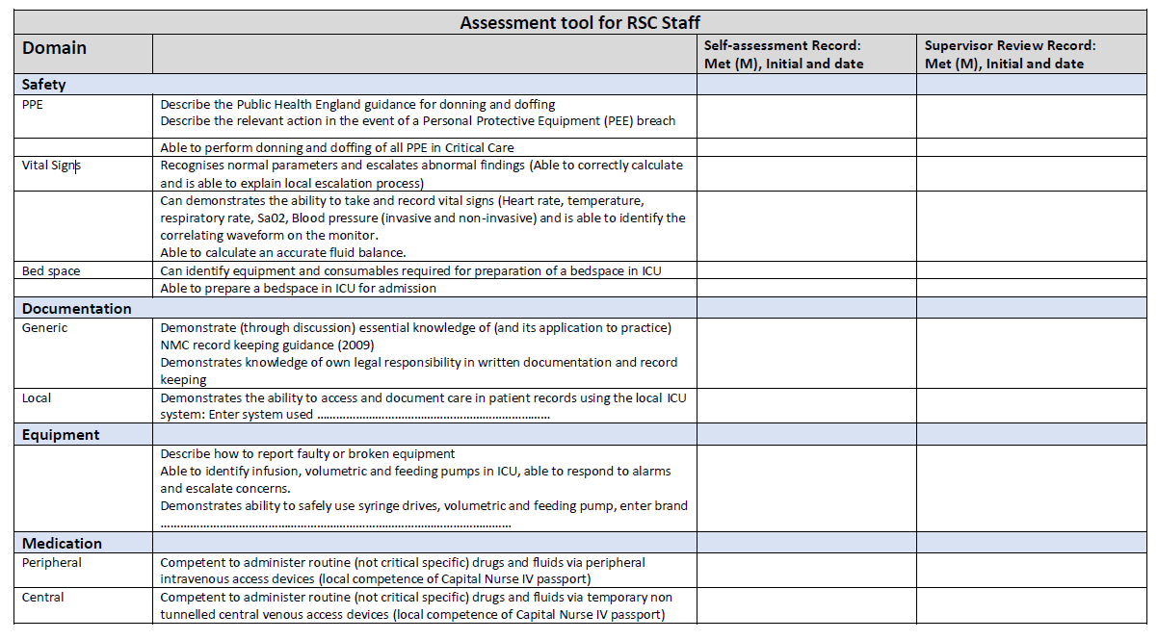
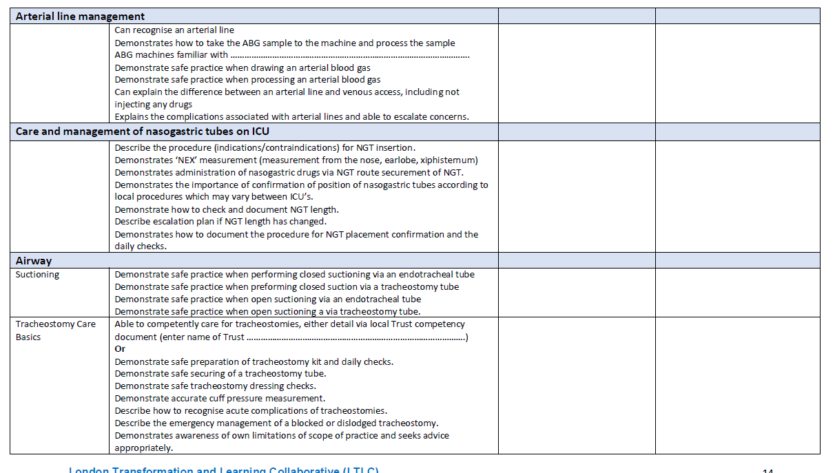
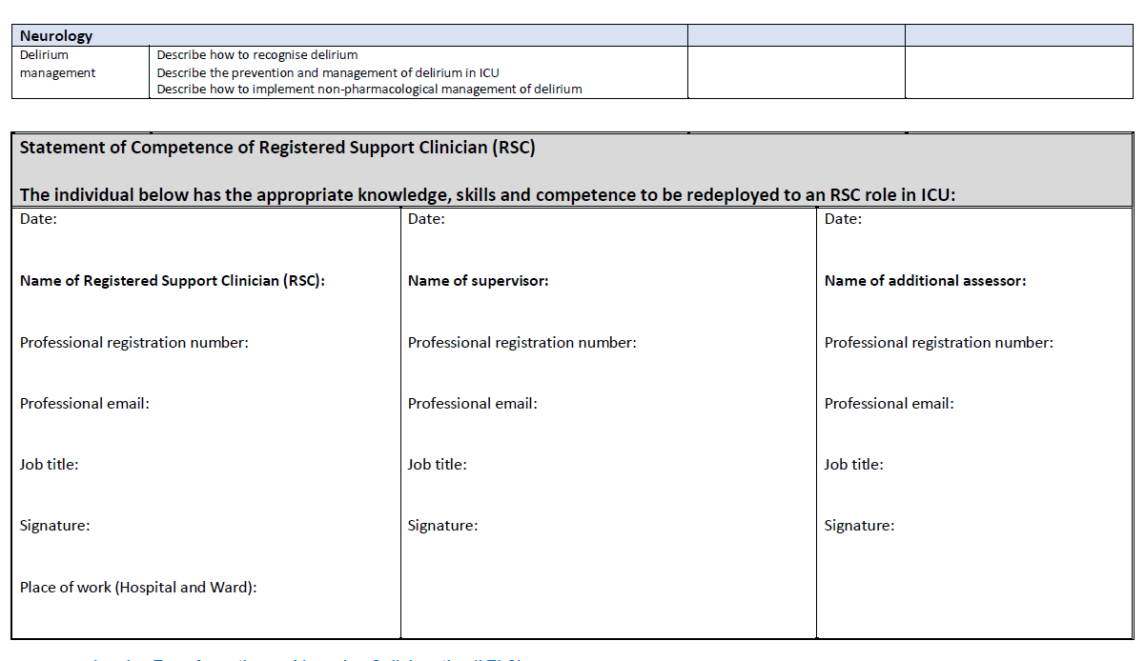
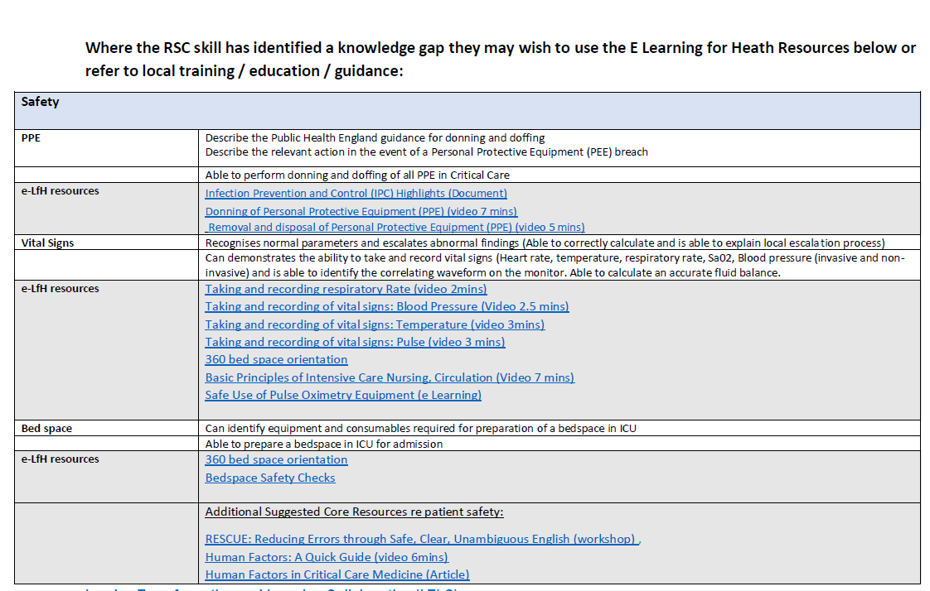
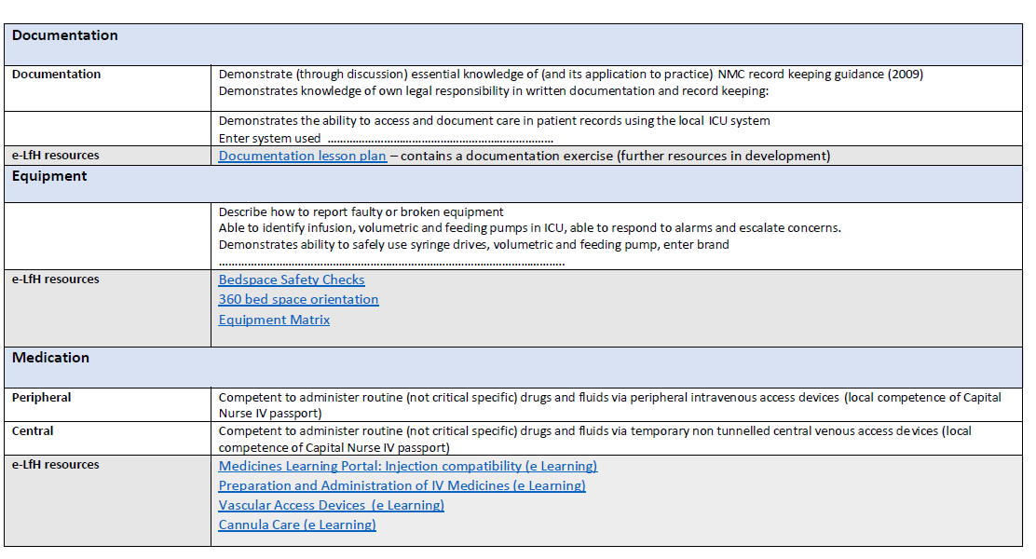
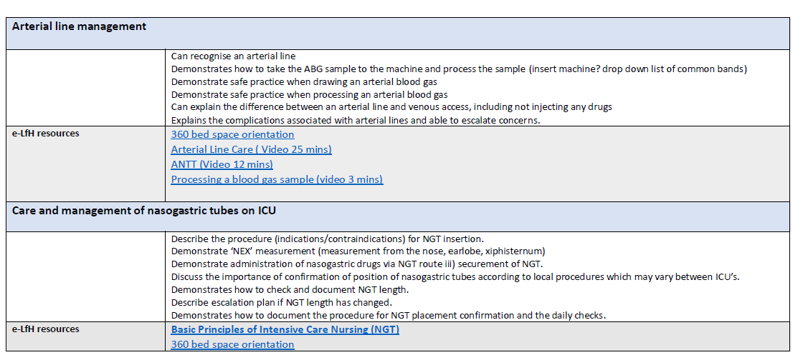
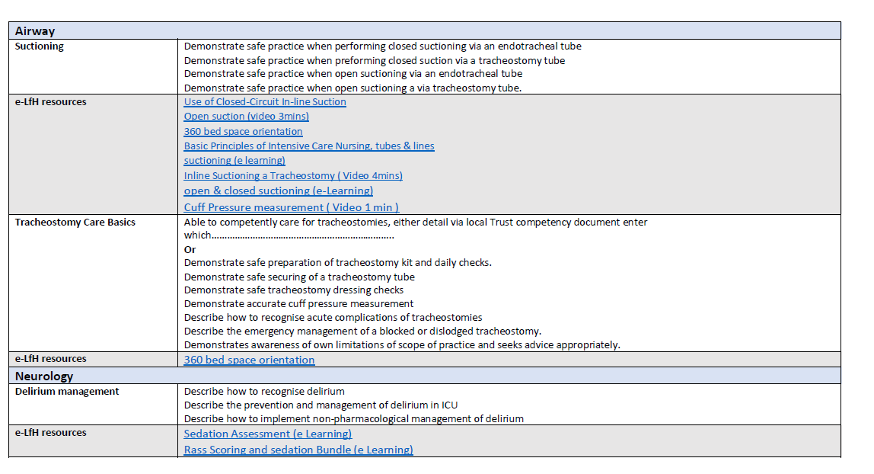
Appendix 4

Medicine Specific Skills
These skills are specific for all registered nurses to practice in the Medicine clinical areas, although some still may be N/A in certain areas.
Please add any Medicine related skills you may need or already have to work safely and effectively in the Medicine care Setting.
Staff are expected to keep this record up to date and continually develop themselves in skills they may be lacking.

Registered Nurse All Fields | Procedure | Method of Delivery | Evidence/Competency | Complete  Sign &Date
Drug Round | Complete bay/ward medication round  Ensure safe practice and appropriate administration is adhered to  Liaise with doctors, pharmacy and the patient regarding discrepancies, doses and stock. | Cascade training at Local/Departmental Level | Completion of the Medicine Safety Workbook and Competencies
Capillary Blood Gases | Obtain capillary blood sample, measure Capillary Blood Gas levels | Cascade training at Local/Departmental Level
Collection of Samples | Collection of the following samples: sputum, urine, stool, wound swabs. | Clinical Skills.net  Cascade training at Local/Departmental Level

Appendix 5

Respiratory Specific Skills
These skills are specific for all registered nurses to practice within the respiratory clinical areas, although some still may be N/A in certain areas.
Please add any Respiratory related skills you may need or already have to work safely and effectively in the Respiratory Setting.
Staff are expected to keep this record up to date and continually develop themselves in skills they may be lacking.

Registered Nurse All Fields | Procedure | Method of Delivery | Evidence/Competency | Complete  Sign &Date
Drug Round | Complete bay/ward medication round  Ensure safe practice and appropriate administration is adhered to  Liaise with doctors, pharmacy and the patient regarding discrepancies, doses and stock. | Cascade training at Local/Departmental Level | Completion of the Medicine Safety Workbook and Competencies
Non-Invasive Ventilation  CPAP | Introduction and awareness of NIV/CPAP | Local/Departmental training
Capillary Blood Gases | Obtain capillary blood sample, measure Capillary Blood Gas levels | Cascade training at Local/Departmental Level

Appendix 6

Surgical Specific Skills
These skills are specific for all registered nurses to practice within the Surgical clinical areas, although some still may be N/A in certain areas.
Please add any surgical related skills you may need or already have to work safely and effectively in the Surgical Setting.
Staff are expected to keep this record up to date and continually develop themselves in skills they may be lacking.

Registered Nurse All Fields | Procedure | Method of Delivery | Evidence/Competency | Complete  Sign &Date
Drug Round | Complete bay/ward medication round  Ensure safe practice and appropriate administration is adhered to  Liaise with doctors, pharmacy and the patient regarding discrepancies, doses and stock. | Cascade training at Local/Departmental Level | Completion of the Medicine Safety Workbook and Competencies
Drain care and Removal |  | Local/Departmental training
PCA usage | Caring for patients with PCA pain relief devices in place.  Competency in refilling medication and maintaining route of administration. | Training Provided by Pain specialist nurse. | Evidence of course completion
Surgical wound care | Caring for post-operative wound sites and dressings, varying types included including orthopaedic and general surgeries. | Local/Departmental training  Wound care covered on Extended clinical induction | Evidence of course completion
Post operative care of a patient | Monitoring of a patient post anaesthetic and surgery. Following trust policy on observation and escalation. | Local/Departmental training

Appendix 7
Diary Log
Agency staff shift recording (Please copy page for continuation)
Please Note Agency Staff Must Still Sign In On Ward For Each Shift, Not Doing So May Result In Delay In Time Sheet Release.

Week commencing:
Monday am | Tuesday am | Wednesday am | Thursday am | Friday am
Monday pm | Tuesday pm | Wednesday pm | Thursday pm | Friday pm
Week commencing:
Monday am | Tuesday am | Wednesday am | Thursday am | Friday am
Monday pm | Tuesday pm | Wednesday pm | Thursday pm | Friday pm
Week commencing:
Monday am | Tuesday am | Wednesday am | Thursday am | Friday am
Monday pm | Tuesday pm | Wednesday pm | Thursday pm | Friday pm

Appendix 8
Reflective Log
Please complete on a regular bases to aid CPD and reflect on any incidents that may of happened.

NAME |  |  | DATE OF SITUATION
CLINICAL SKILLS | YES / NO | COMMUNICATION | YES/NO | KNOWLEDGE DEFICIT | YES/NO

CLINICAL SITUATION
REFLECTION OF SITUATION
MOST IMPORTANT LEARNING FROM THE EXPERIENCE
IDENTIFICATION OF FURTHER LEARNING NEEDS (ACTION PLAN)
SUMMARY OF DISCUSSION

SIGNATURE |  | Date

PLEASE PRINT EXTRA COPIES OF THIS PAGE IF NEEDED
Appendix 9
To be completed by all agency staff new to an area of work.
Name
Temp Assignment
Ward / Department /Area
Assignment Date
Likely Duration / End Date (Tick or Enter Date) | Unknown |  | End Date
Department / Ward Manager

Please complete the following checklist with the ward / department manager as soon as practically possible

To be Completed as Soon as Practically Possible |  |  |  |  | Complete ()  Or N/A
Introduction to COVID 19- Temporary Assignment/ Redeployment
Key ward / department / work areas relevant to my role
Overview temporary assigned role and the roles contribution in the overall function and structure of the ward / department/ work area
Access to the Learning Hub to complete any relevant training modules.
Have been introduced to key members of the team
Provided with Information relevant to the role eg. Standards of Behaviour, PPE requirement and Dress code applicable to temporary assignments working environment
Aware of the confidentiality code of conduct in general and in relation to the media
Have the required access to relevant Trust IT systems needed to carry out the temporary assigned role, including Trust email and Wally
Have confirmed the hours of work / shift patterns and/or ‘On Call’ and bleep arrangements
Have received or have knowledge where to source key documentation used within the ward / department / working environment that maybe necessary to fulfil the temporary assignments requirements
Explanation of the key procedures and equipment used within the ward/department/working environment and how to access this equipment
Explanation of the process and content required for handovers (if appropriate)
Have discussed the outline of my role, responsibilities, levels of authority, work priorities and timelines
Have received an overview of key notification/ feedback/ meetings /committees/ media
Have received knowledge of the method to ramp or escalate issues
Know who to report to and the procedure if that person is not available
Know who to report any circumstances arising that may prevent carrying out the temporary assignment duties eg childcare issues, vehicle issues etc.
Personal Protection Equipment (PPE) Access to & training in operational wearing
Have met ward / department ‘buddy’ (the buddy to offer support and answer any informal questions)
Health, Safety and Security
* Health and safety procedures relevant to the work area, including:
Risk Assessments – as applies under COVID 19 |  | First Aid Arrangements |  | COSHH Procedures
PPE – issue and use (see above) |  | Complete DSE Questionnaire |  | Complete Driving for Work Proforma
*Fire safety procedures and assembly points, including fire exits and evacuation procedures, equipment, emergency numbers and the location of the assembly point
*Security – Security Pass, key (s), name badge, access codes, car parking and permits
Incident reporting procedure using DATIX. How to access and complete the form
*Resuscitation procedures, including the equipment and procedures, the location of the crash trolley and the emergency numbers (if applicable)
*Moving & handling – overview of the moving and handling policy and procedures relevant to the work area.
*Infection prevention procedures, including hand hygiene procedures, bare below elbow, infection status of work area, food hygiene, needlestick injury and prevention
Medicines safety procedures, including pharmacy and local protocols, prescription and administration, medicines common to the work area and standard operating procedures (SOPs)
How to access Steps4Wellness information

I confirm that the content of this checklist has been discussed and understood
Staff member Signature
Manager Signature
Date

PLEASE PRINT EXTRA COPIES OF THIS PAGE IF NEEDED
To ensure compliance please access the Learning Hub and sign as evidence of completion and file
the paper form in the individual’s personal file.

DISCHARGE CHECKLIST
PATIENT DETAILS

Name: ______________________________________ Address: ______________________________________________________________
Date of Birth: ________________________________
Unit/NHS Number: ____________________________
Next of Kin (NOK): _____________________________________
DISCHARGE DETAILS (All patients)

Date of Discharge: ____________________________
Discharge Destination (please state address if different from above): __________________________________________________________
Is patient aware of discharge date & destination: Y/N
Is NOK aware of discharge date & destination: Y/N

Discharge to assess pathway:
Pathway 0: No formal input from health or social care needed □
Pathway 1: Able to return home with support from health &/or social care □
Pathway 2: Rehabilitation or short-term care in a 24-hour bed-based setting □
Pathway 3: On-going 24-hour nursing care likely to be long-term □
Pathway 4: Complex discharge requiring long-term specialist 24-hour care □
GENERAL INFORMATION (All patients)

Is the patient documented as medically safe for discharge? Y/N
Have all cannulae been removed? Y/N
Does the patient have suitable clothing and footwear for discharge? Y/N
Have the patient’s property & valuables been returned including dentures, spectacles etc? Y/N
Does the patient have access to appropriate heating and food on discharge? Y/N
Has the patient been provided with a copy of their discharge letter? Y/N
Does the patient require a fit note? Y/N
Is the UDNACPR being discharged with the patient If applicable? Y/N

Infection Control (All patients)
Does the patient have a history of healthcare associated infection (e.g. MRSA, Clostridium difficile) or other transmissible infection (e.g. COVID-19, influenza, TB)? Y/N please state ___________________________________________
If Yes, has this been included within the discharge letter/ onward referral form with date of diagnosis/ last positive result? Y/N

Pathway 0 & 1 only: Does the patient have appropriate access to their property?
Own keys with patient Y/N
Is there a Key Safe and is there a key in it: Y/N Is the key safe number known (please state) ______________________________
Relative at home: Y/N Please state if not NOK _______________________________________________
Has Homesafe been considered? Y/N

MEDICATION (All patients)

Has the patient received their discharge medication?
Are they or their carers aware of a) any changes to their existing medication? Y/N
b) any new medication that’s started? Y/N
If No please inform Pharmacy

Does the patient require professional assistance to take some or all of their medication i.e. District nurses/ professional carers? Y/N
- If yes, has a referral been made and acknowledged to confirm that the support will be resumed at the time of discharge? Y/N
- If medication is to be administered (except oral forms) to the patient has a DNR4 form been completed and checked by pharmacy? Y/N
- Time medicines last administered ___________________________

Pathway 1 patients only
If the patient is for reablement support with medication on discharge have Pharmacy been informed and a full supply of medication provided [ ] or does the patient have a full supply of medication already at home and reablement have been provided with a full list of medications that the patient is to continue [ ]

FOLLOW UP CARE (All Patients)

Medical/Surgical/Specialist Services
Does the patient know who the name of the consultant who has been responsible for their care on this admission? Y/N
Does the patient require a follow up medical review? Y/N
Has the date/time of this review been given to the patient? Y/N

District Nursing
Does the patient require a District Nursing review? Y/N
Has the patient been referred & by whom? Y/N
Have all dressings, catheters etc been provided? Y/N

Does the patient require Community Response Team (CRT) support on discharge? Y/N

TRANSPORT (All Patients)

How is the patient getting home? ________________________________________________________________
Has Homesafe been considered? ________________________________________________________________
If an ambulance is required has this been booked and for what time? ___________________________________
Does someone need to be at home to meet the ambulance on arrival? If so please state ____________________

PATIENTS DISCHARGED PN PATHWAYS 1-4 ONLY

Deprivation of Liberty Safeguards (DOLS)
If the patient is on a DOLS has a form 9 been completed? Y/N
Have we informed the care provider that the patient has been on a DOLS in hospital and what for? Y/N
If the patient is unbefriended has their IMCA been informed of discharge? Y/N

Safeguarding
Has patient been referred to hospital safeguarding team during their stay? Y/N
If yes: Have the appropriate actions from the safeguarding team been completed? i.e. DATIX/ Safeguarding to Local authority?
Has the social worker been contacted (if requested by safeguarding team) and confirmed they are happy for discharge?
Name of social worker: _______________________________________________
Date and time contacted: _____________________________________________

Has a BODY MAP been completed prior to discharge? Y/N
Has a SSKIN BUNDLE been completed prior to discharge? Y/N
If skin damage present has it been documented by medical photography? Y/N

PATIENTS DISCHARGED ON PATHWAY 1 ONLY

Reablement
Has the patient been referred to Better at home? Y/N
Has reablement leaflet been provided? Y/N
*If support required with medication please ensure the Medication section of the discharge checklist is fully completed.

Care Package
Is this a new care package or a recommencement? Y/N
Please state name & designation of referrer/person confirming recommencement _______________________________________________
Has the care provider been contacted and confirmed start date and time? Y/N
How many visits/day? _______________________________________________
Name of the care provider?___________________________________________
Has all appropriate equipment been issued? Y/N

Moving & Handling
If the patient requires hoisting at home is all equipment in place Y/N
If No, please contact 01942 487605

PATIENTS DISCHARGED ON PATHWAYS 2,3 & 4 ONLY

Has the care provider been contacted and informed of discharge? Y/N
Please state name & designation of staff member who has spoken to the care provider ___________________________________________
Has care provider been provided with a copy of the discharge letter? Y/N
Has a best interest meeting taken place if the patient does not have capacity? Y/N
Comments
_________________________________________________________________________________________________________________
_________________________________________________________________________________________________________________
_________________________________________________________________________________________________________________

Name & designation of staff member completing form

_________________________________________________________________________________________________________________

AT ALL TIMES, STAFF MUST TREAT EVERY INDIVIDUAL WITH RESPECT
AND UPHOLD THEIR RIGHT TO PRIVACY AND DIGNIT

POLICY/SOP MONITORING AND REVIEW ARRANGEMENTS
NAME OF POLICY:

Para | Audit / Monitoring requirement | Method of Audit / Monitoring | Responsible person | Frequency of Audit | Monitoring committee | Evidence | Location

