HIVE Login and Training
- Please use the invite (sent to your registered NHSP email address) to login to the HIVE training system. If you’ve mis-placed the email, use the following links,

https://mftlearninghub.kallidus-suite.com

- Your username is your email address (NHSP registered email address) and your first time only password is HIVE2020! (Unless you’ve logged in before and changed this)

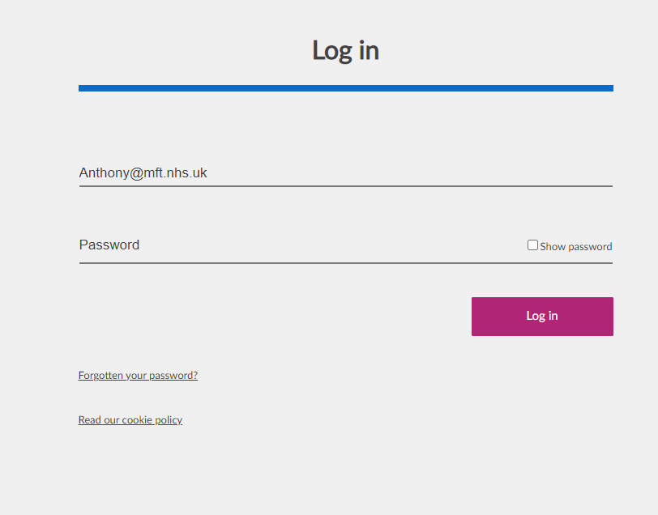

- When logged in, you will see an overview of any training you need to book in (simply click the links to see all your online training, that needs to be completed).
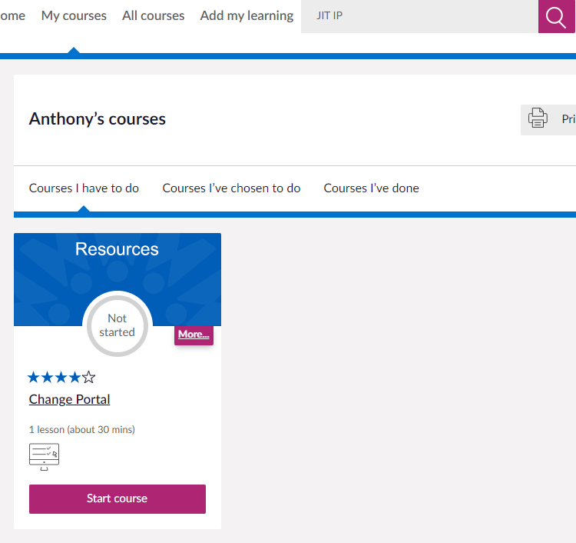

- Also, you will see any courses you’ve already done, to track your progress

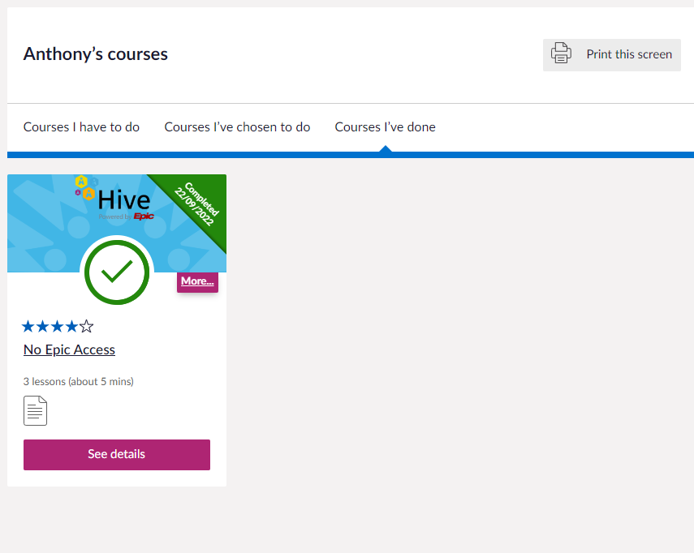

- Unless you specifically need to (for learning reasons) please complete any modules entitled “JIT”, see screenshot below as an example)

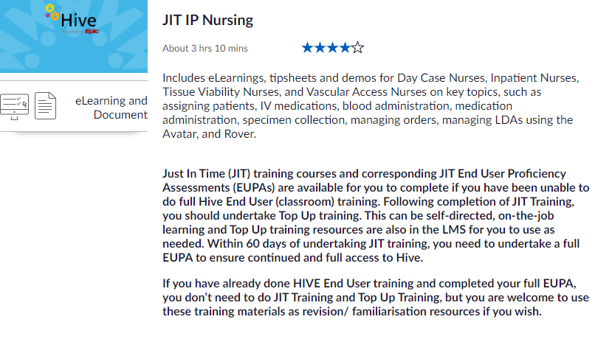

- If you experience any difficulties logging in, your account becomes locked out or becomes inactive, please contact your NHSP office with your details (see below)
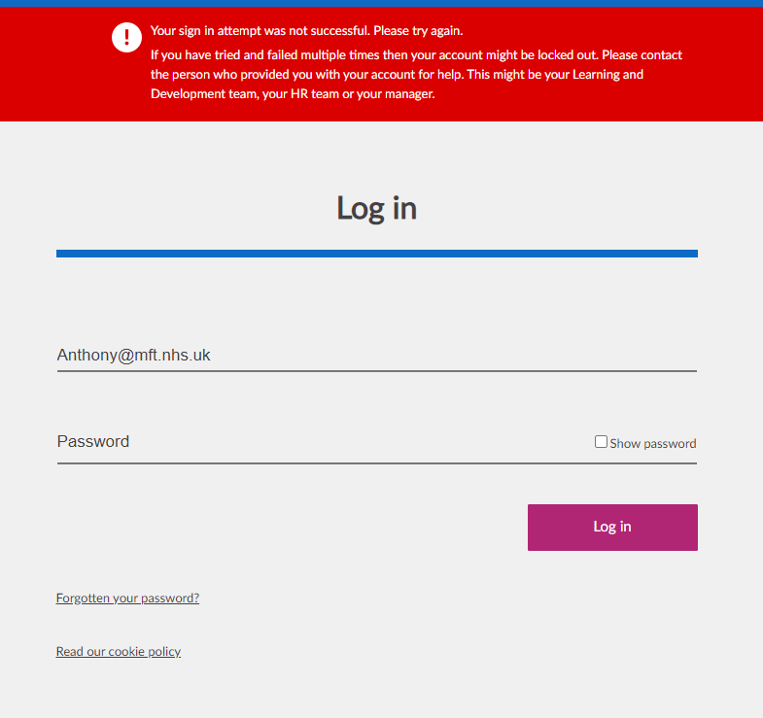

- If you’ve been assigned to the wrong course and need changes, please contact your NHS office with the details of the course change details (see below)

MFT – Manchester Royal Infirmary, St Mary's & Royal Manchester Children's Hospital. oxfordroad.manchester@nhsprofessionals.nhs.uk (03330 144 288)

North Manchester General Hospital. NMGH@nhsprofessionals.nhs.uk (03330 144 288)

Wythenshawe, Trafford, Withington & Altrincham. WTWA@nhsprofessionals.nhs.uk (03330 144 288)

