|  |  |  |  |  |  |  |  |
| --- | --- | --- | --- | --- | --- | --- | --- |
| **Your Name** |  |  | | **National Insurance Number** |  | | |
| **Mobile** | **No** |  |  | **Full Delivery Address** | | | |
| **Email** |  | | **Address Line 1** |  | | | |
|  |  | | **Address Line 2** |  | | | |
| **Date** |  | | **City / Town** |  | | | |
| **Signature** |  | | **County** |  | | **Postcode** |  |

**You are entitled to 3 sets of uniform. Chefs and Food Service Assistants are also entitled to 1 set of footwear. Please select preferred option below by ticking the relevant size.**

Support Services Uniform Order Form

|  |  |  |  |  |  |  |  |  |  |  |  |  |  |  |  |  |  |  |  |  |  |  |  |  |  |  |  |  |  |
| --- | --- | --- | --- | --- | --- | --- | --- | --- | --- | --- | --- | --- | --- | --- | --- | --- | --- | --- | --- | --- | --- | --- | --- | --- | --- | --- | --- | --- | --- |
| **Domestic / House Keeper** | | | | | | | | | | | | | | | | | | | | | | | | | | | | | |
| **Description** | **Colour** | | **6** | | **8** | | **10** | | | **12** | | **14** | | **16** | | **18** | | | **20** | | **22** | | **24** | | | **26** | | **28** | |
| **Female Tunic** | **Eau De Nil** | |  | |  | |  | | |  | |  | |  | |  | | |  | |  | |  | | |  | |  | |
| **Female Trousers** | **Black** | |  | |  | |  | | |  | |  | |  | |  | | |  | |  | |  | | |  | |  | |
| **Description** | | **Colour** | | **26** | | **28** | | **30** | **32** | | **34** | | **36** | | **40** | | **42** | **44** | | **46** | | **48** | | **50** | **52** | | **54** | | **56** |
| **Male Tunic** | | **Eau De Nil** | |  | |  | |  |  | |  | |  | |  | |  |  | |  | |  | |  |  | |  | |  |
| **Male Trousers** | | **Black** | |  | |  | |  |  | |  | |  | |  | |  |  | |  | |  | |  |  | |  | |  |

**\*Please note that the blackout column is not available to order.**

|  |  |  |  |  |  |  |  |  |  |  |  |  |  |  |  |  |  |  |  |  |  |  |  |  |  |  |  |  |  |  |  |  |  |  |
| --- | --- | --- | --- | --- | --- | --- | --- | --- | --- | --- | --- | --- | --- | --- | --- | --- | --- | --- | --- | --- | --- | --- | --- | --- | --- | --- | --- | --- | --- | --- | --- | --- | --- | --- |
| **Domestic / House Keeper – Plymouth Only** | | | | | | | | | | | | | | | | | | | | | | | | | | | | | | | | | | |
| **Description** | | **Colour** | | | **XS** | | | | | **S** | | **M** | | | **L** | | | | | **XL** | | | **XXL** | | | | **3XL** | | | | **4XL** | | | |
| **Unisex Polo Shirt** | | **Navy** | | |  | | | | |  | |  | | |  | | | | |  | | |  | | | |  | | | |  | | | |
| **Description** | | | **Colour** | | | **26** | | **28** | | | **30** | | | **32** | | | **34** | | **36** | | | **38** | | | **40** | | | **42** | | **44** | | | **46** | **48** |
| **Male Trousers** | | | **Black** | | |  | |  | | |  | | |  | | |  | |  | | |  | | |  | | |  | |  | | |  |  |
| **Description** | **Colour** | | | **6** | | | **8** | | **10** | | **12** | | **14** | | | **16** | | **18** | | | **20** | | | **22** | | **24** | | | **26** | | | **28** | | |
| **Female Trousers** | **Black** | | |  | | |  | |  | |  | |  | | |  | |  | | |  | | |  | |  | | |  | | |  | | |

|  |  |  |  |  |  |  |  |  |  |  |  |  |  |  |  |  |  |  |  |  |
| --- | --- | --- | --- | --- | --- | --- | --- | --- | --- | --- | --- | --- | --- | --- | --- | --- | --- | --- | --- | --- |
| **Chefs** | | | | | | | | | | | | | | | | | | | | |
| **Description** | | **Colour** | | | | **XS** | | **S** | | | **M** | | **L** | | **XL** | | | **XXL** | | | |
| **Unisex Chef Jacket** | | **White** | | | |  | |  | | |  | |  | |  | | |  | | | |
| **Unisex Chef Trouser** | | **Black** | | | |  | |  | | |  | |  | |  | | |  | | | |
| **Skull Cap** | | **Black** | | | |  | |  | | |  | |  | |  | | |  | | | |
| **Butchers Stripe Bib** | | **Black / White** | | | |  | |  | | |  | |  | |  | | |  | | | |
| **Description** | **Colour** | | **3** | **4** | **5** | | **6** | | **7** | **8** | | **9** | | **10** | | **11** | **12** | | **13** |
| **Unisex Safety Shoes** | **Black** | |  |  |  | |  | |  |  | |  | |  | |  |  | |  |

|  |  |  |  |  |  |  |  |  |  |  |  |  |  |  |  |  |  |  |  |  |  |  |  |  |  |  |  |  |  |  |  |  |  |  |  |  |  |  |  |  |  |  |  |  |  |
| --- | --- | --- | --- | --- | --- | --- | --- | --- | --- | --- | --- | --- | --- | --- | --- | --- | --- | --- | --- | --- | --- | --- | --- | --- | --- | --- | --- | --- | --- | --- | --- | --- | --- | --- | --- | --- | --- | --- | --- | --- | --- | --- | --- | --- | --- |
| **Food Services Assistant (FSA)** | | | | | | | | | | | | | | | | | | | | | | | | | | | | | | | | | | | | | | | | | | | | | |
| **Description** | **Colour** | | | | | **XS** | | | **S** | | | | | | **M** | | | | | **L** | | | | | **XL** | | | | | **XXL** | | | | | | **3XL** | | | | | **4XL** | | | | |
| **Unisex Polo Shirts** | **Navy** | | | | |  | | |  | | | | | |  | | | | |  | | | | |  | | | | |  | | | | | |  | | | | |  | | | | |
| **Description** | | | | **Colour** | | | | | | **6** | | | **8** | | | **10** | | **12** | | | | **14** | | | | **16** | | | **18** | | | | **20** | | | | **22** | | | **24** | | | | **26** | **28** | |
| **Female Trousers** | | | | **Black** | | | | | |  | | |  | | |  | |  | | | |  | | | |  | | |  | | | |  | | | |  | | |  | | | |  |  | |
| **Description** | | | **Colour** | | | | **26** | | | | **28** | | | **30** | | | **32** | | | | **34** | | | **34** | | | | **36** | | | | **40** | | | **42** | | | | **44** | | | | **46** | | **48** |
| **Male Trousers** | | | **Black** | | | |  | | | |  | | |  | | |  | | | |  | | |  | | | |  | | | |  | | |  | | | |  | | | |  | |  |
| **Description** | | **Size** | | | **3** | | | **4** | | | | **5** | | | | **6** | | | **7** | | | | **8** | | | | **9** | | | | **10** | | | **11** | | | | **12** | | | | **13** | | | |
| **Unisex Safety Shoes** | | **Black** | | |  | | |  | | | |  | | | |  | | |  | | | |  | | | |  | | | |  | | |  | | | |  | | | |  | | | |

|  |  |  |  |  |  |  |  |  |  |  |  |  |  |  |  |  |  |  |  |  |  |  |  |  |  |  |  |  |  |  |  |  |  |  |  |  |  |  |  |  |  |  |
| --- | --- | --- | --- | --- | --- | --- | --- | --- | --- | --- | --- | --- | --- | --- | --- | --- | --- | --- | --- | --- | --- | --- | --- | --- | --- | --- | --- | --- | --- | --- | --- | --- | --- | --- | --- | --- | --- | --- | --- | --- | --- | --- |
| **Porters** | | | | | | | | | | | | | | | | | | | | | | | | | | | | | | | | | | | | | | | | | | |
| **Description** | | | **Colour** | | | | **XS** | | | | | **S** | | | | **M** | | | | | **L** | | | | | **XL** | | | | **XXL** | | | | | **3XL** | | | | **4XL** | | | |
| **Unisex Polo Shirt** | | | **White** | | | |  | | | | |  | | | |  | | | | |  | | | | |  | | | |  | | | | |  | | | |  | | | |
| **Description** | **Colour** | | | **6** | **8** | | | **10** | | **12** | | | **14** | | **16** | | | **18** | | **20** | | **22** | | **24** | | | **26** | | **28** | | | **30** | | **32** | | | **34** | | | **36** | | **38** |
| **Female Trousers** | **Navy** | | |  |  | | |  | |  | | |  | |  | | |  | |  | |  | |  | | |  | |  | | |  | |  | | |  | | |  | |  |
| **Description** | | **Colour** | | | | **26** | | | **28** | | **30** | | | **32** | | | **34** | | **36** | | | | **38** | | **40** | | | **42** | | | **44** | | **46** | | | **48** | | **50** | | | **52** | | |
| **Male Trousers** | | **Navy** | | | |  | | |  | |  | | |  | | |  | |  | | | |  | |  | | |  | | |  | |  | | |  | |  | | |  | | |

|  |
| --- |
| **PLEASE NOTE:**  **Illegible orders will not be processed.**  **Black Trousers are regular fit with inside leg of 31’’.**  **Navy Trousers are supplied unhemmed – iron on hemming tape is provided.**  **If you are requiring garments outside these size ranges, please email – Uniform@NHSProfessionals.nhs.uk** |

|  |  |  |  |  |  |  |  |  |  |  |  |  |
| --- | --- | --- | --- | --- | --- | --- | --- | --- | --- | --- | --- | --- |
| **Size** | **6** | **8** | **10** | **12**  Female Size Chart for Eau De Nil Tunic | **14** | **16** | **18** | **20** | **22** | **24** | **26** | **28** |
| **Bust in Inches** | **31’’** | **32’’** | **34’’** | **36’’** | **38’’** | **40’’** | **42’’** | **44’’** | **46’’** | **48’’** | **50’’** | **52’’** |
| **Bust in CMS** | **78** | **81** | **86** | **91** | **96** | **101** | **106** | **111** | **116** | **121** | **127** | **132** |

|  |  |  |  |  |  |  |  |  |  |  |  |  |
| --- | --- | --- | --- | --- | --- | --- | --- | --- | --- | --- | --- | --- |
| **Size** | **34** | **36** | **38**  Male Size Chart for Eau De Nil Tunic | **40** | **42** | **44** | **46** | **48** | **50** | **52** | **54** | **56** |
| **Chest in Inches** | **34’’** | **36’’** | **38’’** | **40’’** | **42’’** | **44’’** | **46’’** | **48’’** | **50’’** | **52’’** | **54’’** | **56’’** |
| **Chest in CMS** | **91** | **97** | **102** | **107** | **109** | **112** | **117** | **122** | **127** | **132** | **137** | **142** |

|  |  |  |  |  |  |  |  |  |  |
| --- | --- | --- | --- | --- | --- | --- | --- | --- | --- |
| **Size** | **XS** | **S** | **M**  Unisex Size Chart for Polo Shirts | **L** | **XL** | **XXL** | **2XL** | **3XL** | **4XL** |
| **Chest in Inches** | **36 – 38’’** | **38 – 40’’** | **40 – 42’’** | **42 – 44’’** | **44 – 46’’** | **46 – 48’’** | **48 – 50’’** | **50 – 52’’** | **52 – 54’’** |
| **Chest in CMS** | **91 – 96** | **96 – 101** | **101 - 106** | **106 – 111** | **111 - 116** | **116 – 121** | **121 - 127** | **127 - 132** | **132 - 137** |

|  |
| --- |
| **These measurements are a guide only. You may find that fits vary from person to person depending upon shape.** |

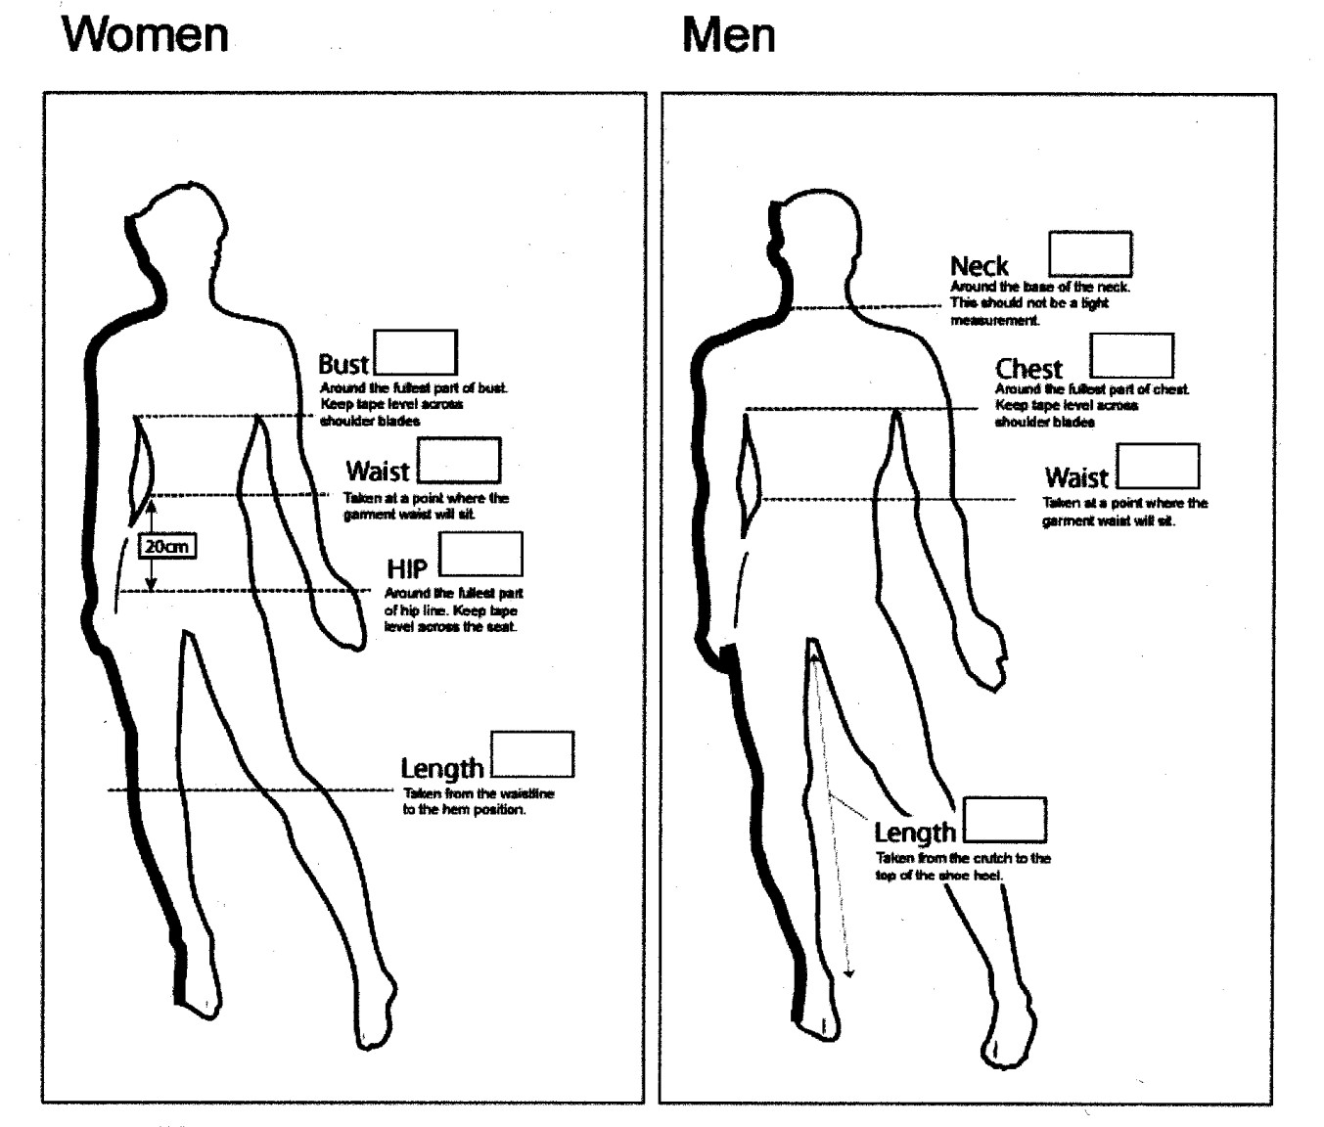

|  |
| --- |
| **To ensure a good fit please use the guidelines in the following diagram to help you to obtain body measurements and then compare to the accompanying chart to see what size you need to order.**  **Please note:**  DO NOT add anything to your measurements for comfort, as this will have been taken into account at the manufacturing stage of the garment.  Takes measurement over light clothing and as close to the body as possible, without being too tight.  Uniform clothing must be comfortable in its use, therefore please be as accurate as possible when taking your details.  Do not order sizes against anticipated weight loss.  This guide is formulated with the intended fit of your uniform in mind and does not cater for personal preference or style. |

|  |
| --- |
| **Once fully completed, please sign and either post or email your uniform order form to :-**  **Post:** Compliance Team NHS Professionals Ltd  NHS Professionals Ltd  Breakspear Park  Breakspear Way  Hemel Hempstead  HP2 4TZ  **Email:** Scan or attach your form in an email to: [Uniform@NHSProfessionals.nhs.uk](mailto:Uniform@NHSProfessionals.nhs.uk) |

|  |
| --- |
| **Any queries regarding your order, please contact Debbie Greenwood at Tibard on email –** [**debb@Tibard.co.uk**](mailto:debb@Tibard.co.uk) **or call – 0161 342 1000 once you have received your order reference number in an email.** |

Uniform Order Form NHSP V11 MAY21